[](http://www.dailyliberal.com.au/)

Dubbo Hospital's 'turnaround' leads to major award

Kim Bartley  
24 Feb 2017, 3 p.m.

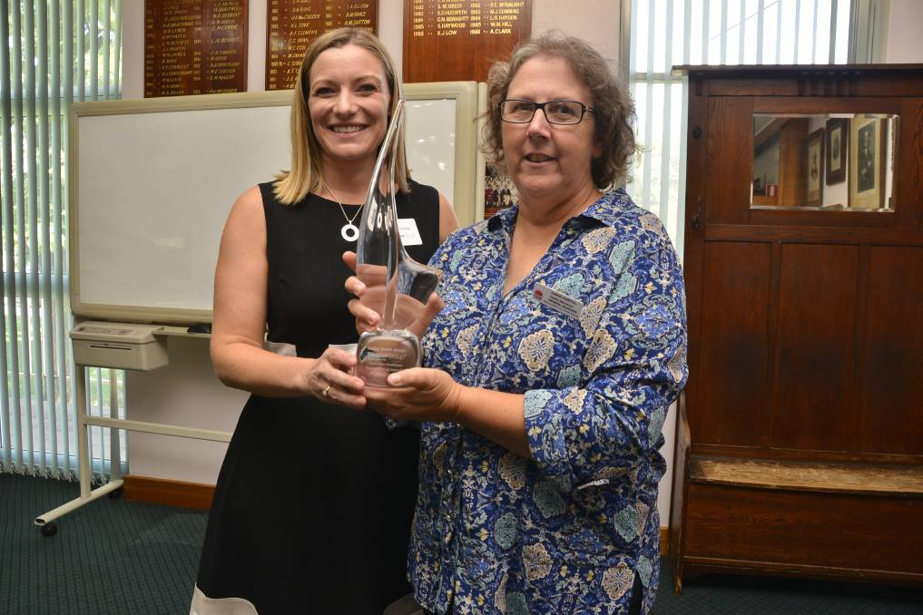

MAJOR AWARD: The Studer Group's Michele Dobe presents Dubbo Hospital general manager Debbie Bickerton with the Studer Group Australian Healthcare Organisation of Distinction award. Photo: PAIGE WILLIAMS

A major award and high praise from Western NSW Local Health District chief executive Scott McLachlan confirms that Dubbo Hospital is back on its “front foot”.

This week general manager Debbie Bickerton accepted the Studer Group Australian Healthcare Organisation of Distinction award on behalf of the hospital’s almost 1000 employees. It recognises a “turnaround” at the hospital across “pillars” ranging from the delivery of safe and high quality services to financial management.

Ms Bickerton reported at the presentation that Mr McLachlan was “not aware of any other facility in Australia that has had a turnaround like Dubbo”. He calls it “amazing”, a sentiment shared by the general manager who “could not be prouder” of her staff.

The Studer Group, a healthcare consulting firm working in partnership with the hospital since 2013, reports of the implementation of the Living Well Together program, focused on generating teamwork and the “best possible experience and outcomes for patients”. Ms Bickerton said the program included “hourly rounding” involving nurses asking every one of their patients if they “need anything”. The results of the strategy include a 50 per cent drop in the rate of falls and a 38 per cent decline in patient complaints. “We are down to 0.8 falls per 1000 bed days as compared with the district’s benchmark of 3.2,” Ms Bickerton said. The general manager said hand hygiene was seen as a “real indicator” of the culture of a facility. “We started off at 65 per cent and now it’s in the high 80s,” she said.

Establishment of a stable executive team had supported the financial turnaround. “When I started here in 2012 we were nearly $20 million unfavourable,” Ms Bickerton said. “Last year we came out $29,000 favourable.” Contributing factors included the introduction of activity-based funding, correction of “historical budgets” that did not reflect growth, more efficient rosters, and much less reliance on costly locums through recruitment of permanent doctors, both senior and junior. Another four specialists will start work at the hospital in the next couple of months. Their positions have been filled by locums.

The award is only one of two handed out annually in Australia by the Studer Group that also operates overseas. Ms Bickerton said the hospital would be tackling “preventable admissions” in the future. “I feel like we’re definitely on the front foot now,” she said.